
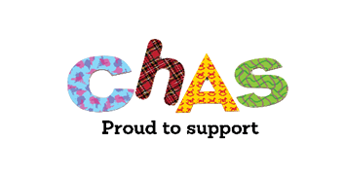
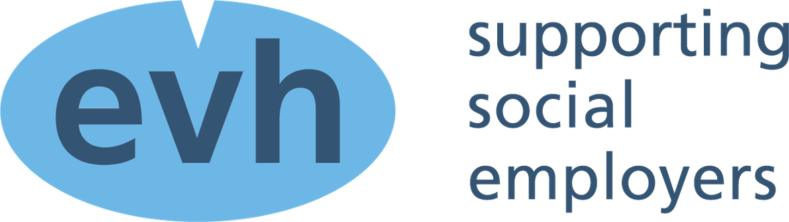

EVH 2026 CHAS Appeal
Be in with the chance of winning a half day training session

PLEDGE SHEET
The more you pledge the higher the number of times your organisation goes into the draw!
Name of organisation:

Amount Pledged | Winning Changes | Only select on box
£50 | 1
£80 | 2
£120 | 3
£160 | 4
£200 | 6
£250 | 8
£300 | 10
£350 | 12
Organisations can either pay via invoice or BACS please select which option below

Invoice BACS

Please see our bank details below if paying by BACS and make sure you add CHAS as the
reference when making payment. Also return this pledge sheet, we don’t want you to miss out on the chance to win.

Bank name: Virgin Media Account name: EVH Limited Account Sort Code: 82-20-00 Account Number: 70318297

Please return the form no later than 5.00pm on Tuesday 28 April.

The winning organisation will be announced on Wednesday 29 2026.

THANK YOU FOR YOUR SUPPORT

