
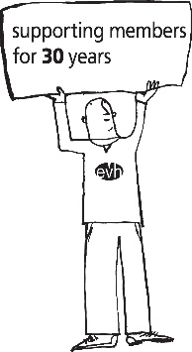



Booking Form

Event: Mindfulness Session
Date: Tuesday 27 January 2026, 2.00pm – 3.00pm
Location: Online via Zoom
Costs: EVH Members only - Free

This session is free for members to attend however we require all delegates to pre book their place. Please note that bookings which are withdrawn without a substitution 48 hours before the event will be charged a £20 administration fee (this will be donated to CHAS) as will those who do not attend. We will accept substitutions at any time.

Please complete the following and return by email to Events@evh.org.uk. There is no limit to the number of spaces you can book.

Name of delegate joining via Zoom
Organisation
Email address to send zoom invitation to
Name of delegate joining via Zoom
Organisation
Email address to send zoom invitation to

The contact person making the booking will receive confirmation from a member of the Events Team to confirm their delegate’s place. The zoom joining instructions will be sent nearer the event, direct to the delegate at the email provided above. If you have any questions, please get in touch by email – Events@evh.org.uk.

