

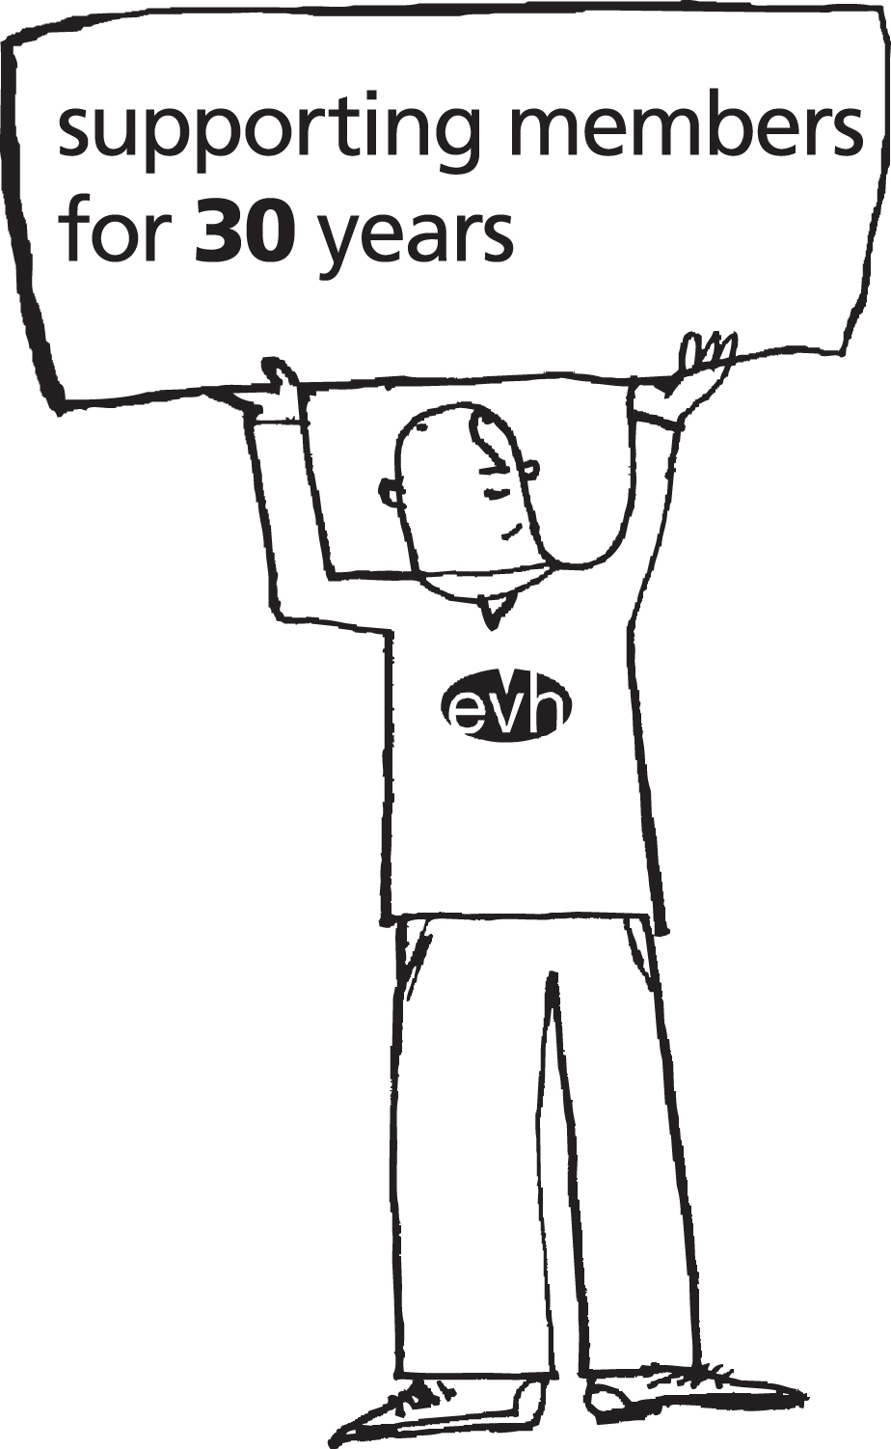
Governing Body Member Event
Governing Body Member Event
Booking Form

Event: Service Sharing & Succession Planning
Date: Wednesday 8 June 2016 (9.45 am till around 12.30 pm)
Location: Betty’s Room, EVH Office, 137 Sauchiehall Street, Glasgow
Cost: EVH members £75 – No VAT (Non-members, places permitting, £225 plus VAT)

Background

Service sharing is very much back in play as small to medium sized organisations look to maximise strategic nous whilst still keeping costs in check. In the midst of all this, succession planning considerations can also impact.

What is the business case which supports this approach, and how can Governing Bodies test the effectiveness of any sharing arrangements that are put in place?

This event will address these points and much more besides. Main sessions will be led by Paul McNeil of HR+, who will examine the business case behind the model; and John Mulholland of Forgewood Housing Co-op who will describe methods of evaluating and auditing service benefits. Jammed in the middle, Eamonn Connolly of EVH will briefly cover succession planning.

The session will end with a relaxed buffet lunch and good networking opportunities. Restricted delegate numbers will ensure those attending get more from this session than would be possible in a mass event. So early booking is recommended, see overleaf for booking conditions.

Please complete the following and return by email, post or fax to:

EVH, 5th Floor, 137 Sauchiehall Street, Glasgow G2 3EW. Email: Events@evh.org.uk / Fax: 0141 352 7449. Or book online at the Events Section of the website www.evh.org.uk

Contact Name:
Organisation:
Address:
Postcode:
Phone:
Email:
P.O. No:

Delegate 1
Name | Job Title | Email
 | Committee/Board member
Other requirements for example, mobility/dietary

Delegate 2

Name | Job Title | Email
 | Committee/Board member
Other requirements for example, mobility/dietary

Delegate 3

Name | Job Title | Email
 | Committee/Board member
Other requirements for example, mobility/dietary

The contact person making the booking will receive a confirmation email.

Booking Conditions

All bookings must be made by noon on Wednesday 1 June 2016. Booking requests made after that time cannot be guaranteed.

Please make sure that delegates’ names are included as you would like them to appear on the delegate list and name badges.

Joining Instructions

The contact person making the booking will receive an e-mail confirmation confirming your place(s). Approximately one week prior to the event you will also receive final joining instructions.

