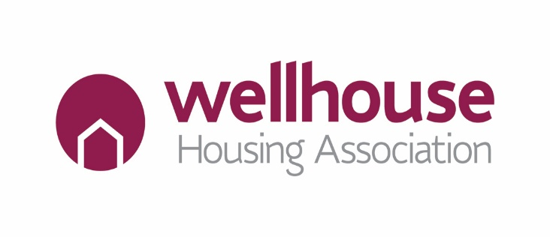

Wellhouse Housing Association
Competency based Framework

What are Competencies?
- Competencies are the personal attributes or underlying characteristics that shape the way we carry out our roles. They are a combination of the skills, knowledge, attitudes and behaviours that are required by everyone if we are to demonstrate our core values in the way that we work. They focus on how tasks are achieved not what is achieved.

Who does the Competency Based Framework apply to and how will it be utilised?
- It applies to everyone in the Association as all colleagues are expected to always demonstrate the core values, however Senior Managers are required to demonstrate additional competencies which ensure the framework is embedded across the Association.

- It is used as a recruitment tool to attract and employ those who demonstrate the core values.

- Each competency is based on one of the Association’s core values. This enables all staff members to clearly see what is expected of them and what they can expect of colleagues too.

- The framework sets out both positive and negative indicators to help colleagues understand what behaviour is expected and what behaviour is unacceptable.

- Colleagues are expected to consistently demonstrate the level of competence required for their role.

- Managers will use the competencies to coach and develop colleagues on a day-to-day basis.

Our Values
We are committed to ensuring that the behaviour of our people reflects the importance we place on our values. Wellhouse’ values are the basis for the work we do in partnership with our tenants, our people and other stakeholders.
  CARING  we will strive to be the best we can for our communities. |  |   OPEN  we will be open and honest about what we do.
  RESPECTFUL  we trust and respect our customers and each other. |  |   EMPATHY  we will listen and see things from our customers perspective.

Wellhouse Competency Framework 2025-2028
Value and Competency 1- Caring
All Staff | Senior Managers
- You are willing to work in new and different ways to meet other people’s needs.  - You take ownership of customers’ issues as the first point of contact.  - You spot mistakes or problems and apologise for them.  - You keep customers informed by giving them as much suitable and correct information as you can.  - You welcome customers with eye contact, a smile and welcoming greeting.  - You remain calm and assertive when faced with challenging and/or aggressive customers. | - You promote a positive, welcoming, inclusive team culture.  - You act as a role model for delivering excellent customer service.  - You realise when more than a standard response is needed and act as appropriate.  - You evaluate customer satisfaction data, changing processes and strategy where necessary and ensure customer focus is embedded within policies and procedures.  - You develop and change services to meet the long-term needs of customers.  - You coach team members in developing their customer service skills and demonstrate the competencies listed in column 1.
Unacceptable and unhelpful behaviours
X Focused on own agenda. X Does not take ownership of problems and passes to others.

X Fails to take responsibility for decisions. X Is inflexible in ways of working and decision making.

X Demonstrates negative body language. X Reacts inappropriately when faced with challenging customers.

Value and Competency 2 – Open
All Staff | Senior Managers
- You are willing to admit you have made a mistake and actively learn from it.  - You share knowledge and expertise with others without hesitation.  - You offer constructive feedback to others in a respectful way.  - You inform your line manager about recurring problems, waste or inefficiency.  - You recognise you do not have all the answers and are open to learning.  - You seek and provide information to achieve targets, objectives and improve performance. | - You actively challenge and address “silo attitudes” to encourage working relationships both inside and outside Wellhouse HA.  - You demonstrate integrity, fairness and consistency in decision making.  - You promote a culture of openness and sharing information and operate and encourage an ‘open door’ policy.  - You facilitate ‘top down, bottom up’ communication.  - You use feedback and observations made to improve the efficiency and effectiveness of processes, systems and practices.  - You create an environment that allows and encourages people to share best practice and improve the way they work.
Unacceptable and unhelpful behaviours
X Unwilling to support colleagues or share knowledge. X Tolerates inefficiency.

X Rejects new ideas without providing justification/reason. X Does not recognise or embrace training.

X Misses opportunities to build new relationships. X Operates in departmental silos without regard to wider organisation.

Value and Competency 3 – Respectful
All Staff | Senior Managers
- Demonstrates respect, honesty and professionalism.  - You treat others with respect.  - You use appropriate language and behaviour when dealing with others.  - You challenge discriminatory behaviour and language and explain why it is unacceptable (reporting to a line manager if you do not feel comfortable challenging).  - You show respect for all cultures, religions and beliefs.  - You avoid pre-judging people. | - You treat everyone with respect, valuing their contributions and demonstrate fairness, integrity and consistency in all dealings with others.  - You lead and set an example of the expected behaviour and performance for all Wellhouse HA staff  - You make the most of the diverse skills and experience of others.  - You ensure that opportunities are made equally available to everyone and intervene when the behaviour of others undermines equality of opportunity and diversity  - You deal efficiently and fairly with clear cases of evidenced inappropriate behaviour  - You ensure that respect and equality are embedded in the Association’s policies and procedures
Unacceptable and unhelpful behaviours
X Excludes others X Fails to call out discriminatory or unacceptable behaviour

X Forms preconceived ideas about people X Shouting or speaking in a hostile way

X Exhibit favouritism and do not provide equal opportunity X Demeaning or putting down others

Value and Competency 4 – Empathy
All Staff | Senior Managers
- You reflect and have an awareness of the consequences of decisions taken.  - You treat others as you would like to be treated yourself.  - You show empathy and sensitivity in dealing with others.  - You celebrate individual and organisational success.  - You listen actively to fully understand a situation before reacting.  - You ask questions to better understand another person’s perspective. | - You coach team members to behave in an empathetic manner and deliver feedback on their skills.  - You intervene when it is apparent that a team member is not behaving empathetically.  - You act as a role model for active listening and set standards of acceptability.  - You encourage flexible outcomes dependant on the needs of the individual.  - You promote having conversations with a wide range of people about their feelings and experiences.  - Encourage self-reflection and examine any existing biases.
Unacceptable and unhelpful behaviours
X Fails to listen X Self-centred or self-focused and doesn’t consider others

X Does not consider the impact of how they interact with others X Impatient with other people, their difficulties and their emotions

X Criticises harshly and often X Unwilling to forgive others for mistakes or weaknesses

