

Repairs & Maintenance Assistant
Information pack

August 2026

About Us – Provanhall Housing Association
Provanhall Housing Association is a community-focused housing provider based in the heart of Greater Easterhouse, Glasgow. With 533 homes under management, we are committed to delivering high quality, affordable housing and supporting the wellbeing and prosperity of our tenants.
We take pride in being a locally rooted organisation, working closely with residents and partners to build a stronger, more vibrant community. Our team is passionate about providing excellent customer service and continuously improving the way we work to meet the evolving needs of our tenants.
At Provanhall, we believe that a good home is the foundation for a good life—and we are here to make that a reality for everyone in our community.
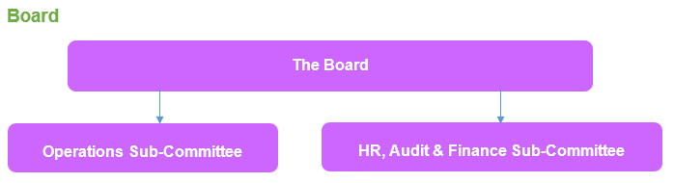
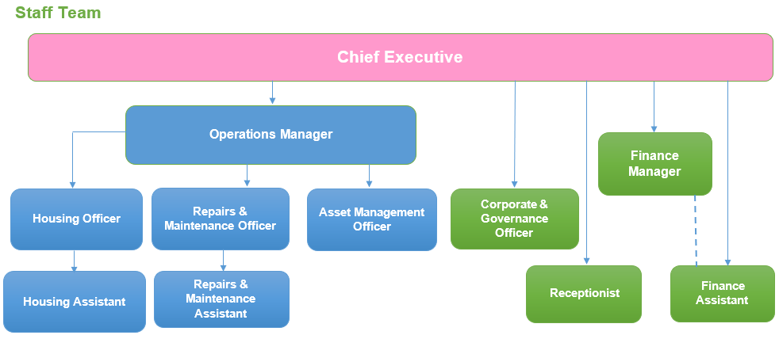

Benefits & Support at Provanhall Housing Association

At Provanhall Housing Association, we value our team and are committed to providing a supportive and rewarding working environment. Our staff enjoy a range of benefits designed to promote wellbeing, career development, and work-life balance.

Pension Scheme
We offer access to the SHAPS Defined Contribution Pension Scheme, with flexible options:
- Employee contributions: 3% to 5%
- Employer contributions: 6% to 10%

Career Development
We invest in your growth. Whether you are looking to enhance your current skills or progress into management, we will support you with access to:
- Professional qualifications
- Vocational training
- On-the-job learning opportunities

Annual Leave
Our generous leave package includes:
- 40 days annual leave and public holidays annualized (as set by Employers in Voluntary Housing - EVH) Leave is pro-rated for part-time staff and runs from 1 April to 31 March.

Family-Friendly Policies
We understand the importance of balancing work and personal life. We offer:
- Support for changing personal circumstances
- Maternity, Paternity & Adoption Leave
- We provide enhanced support for parents and carers, including:
- Generous leave arrangements above statutory minimums
- Continued recognition of your contribution during leave periods
- Flexible working arrangements
- Flexitime with opportunity to work 9-day fortnights

Special Leave
Staff can apply for additional time off in specific circumstances. Special leave may be granted with or without pay, depending on the situation.

Company Sick Pay
We provide paid leave during absence depending on your length of service. Sick leave on full pay will be paid for a period between 5 and 26 weeks in any 12-month rolling period (subject to your length of service) and thereafter sick leave on half pay.

Eye Care Support
We provide you an allowance each year, which you can apply for towards spectacles that you require for VDU use. The amount is set by EVH annually.

Employee Assistance Programme (EAP)
Balancing the demands of work and your personal life is not always easy. Our Employee Assistance Programme is a free confidential 24-hour service providing specialist support and information for you and your immediate family on life management, health information and personal support for the times when you need it most.

Flu Vaccinations
To protect our staff annually we will reimburse you for a flu vaccination fee arranged in your own time.

Cycle to Work
We operate a salary sacrifice cycle to work scheme, in partnership with Evans Cycles. This allows staff members to make tax and NI savings through salary sacrifice.

31.5 hour working week
We offer a 31.5 hour week for full time equivalent employees – our office closes at 12:30 on a Friday afternoon to accommodate this.

Electric Vehicle Salary Sacrifice
We offer an employee electric vehicle scheme to permanent employees subject to a 12-week voluntary notice period change to your contract.

Subsidised gym membership
We offer a subsidised gym membership rate at a local gym for staff.

Private healthcare with Benenden Health
We offer a non-contributory benefit package.

Our Recruitment Process

Selection Process
Once the job advert is closed, your information will be sent for shortlisting to the recruitment panel. You will be notified whether or not your application will be progressed to the next stage of the selection process. The selection process varies between roles but as a minimum normally includes an assessment of the application form/personal statement and a competency-based interview.

Details of what the selection process will involve for the role you have applied for will be included in the Recruitment Pack, with further information provided to you as necessary during the selection process.

Reserve List
Where the selection process identifies more appointable candidates than positions available, a reserve list will be retained for up to 6 months for future appointments of similar grade. There will be no need for further assessment.

Pre-appointment Checks
If you are successful, we will complete enquiries into employment history, qualifications, and relevant disclosure check to ensure that you are qualified and suitable for the appointment.
When the pre-employment enquiries are satisfactorily completed, we will make you a formal offer of appointment and you to take up the appointment as soon as possible, subject to any notice period you may have with your current employer.

Criminal Convictions
For most roles, successful candidates will be subject to a Disclosure check prior to an offer of employment being confirmed. The level of Disclosure check is role specific. You will be sent a Criminal Conviction Declaration Form along with your invite to interview, which you must complete and return.

Induction
Successful candidates will be enrolled onto our Induction Programme for the first three months into your role.

Probation
We operate a probationary period for all new employees which forms part of the contract of employment. This is managed in conjunction with our Induction Process

Data Protection Act 2018 and the General Data Protection Regulation (GDPR)

Personal information that you provide during any stage of the recruitment and selection process will be treated in accordance with the Data Protection Act 2018 and the General Data Protection Regulation (GDPR).

Equality & Diversity
We are committed to ensuring that everyone in here, and those who encounter the organisation, including prospective candidates and job applicants, are treated fairly, with dignity and respect. Provanhall Housing is committed to advancing equality of opportunity in recruitment and selection, regardless of age, disability, race, religion or belief, marital or civil partnership status, pregnancy or maternity, gender reassignment, gender, sexual orientation or any other personal characteristic or status.

Blind Recruitment
To ensure we support this commitment, our selection approach before the interview stage is managed anonymously, commonly referred to as ‘name blind’ recruitment. This means that your personal details will be removed from your application during the shortlisting process.

Disability Confident Scheme & Reasonable Adjustments
Provanhall Housing is a member of the Disability Confident scheme and under the terms of the scheme, all candidates who consider themselves to be disabled in terms of the Equality Act 2010 and who meet the essential minimum criteria for the post, will be progressed to the next stage of the selection process.
We will also ensure that we consider and implement any reasonable adjustments you may require to participate in the selection process or during the course of your employment, should you be successful in securing a post. Please ensure that you notify us of any reasonable adjustments’ requests at the earliest possible opportunity to allow us to make the necessary arrangements.

Diversity Monitoring
The application process includes an Equal Opportunity Monitoring Form. The information you provide here will be treated in the strictest confidence and will be retained for monitoring purposes. Apart from our Director, who is responsible for HR procedures, it will be kept separately from your application form and will not be made available or disclosed to those involved in the selection decision.

Person specification – Repairs & Maintenance Assistant
Qualifications | Essential | Desirable
Level 3 CIH qualification in Repairs & Maintenance or equivalent. |  | P
Educated to at least Higher level in English or Administration, or equivalent relevant administrative experience. | P
Basic knowledge of Repairs Legislation. | P
Understanding of the Scottish Housing Regulatory Framework and the Scottish Social Housing Charter, including ARC requirements |  | P
Job Knowledge | Essential | Desirable
Receive and progress repairs notifications. | P
Contribute to the prompt and efficient turnaround of void properties. | P
Progress all aspects of reactive, voids, planned and cyclical maintenance. | P
Process invoices and authorise payments in accordance with agreed financial approval levels. |  | P
Experience in producing performance reports and statistical data. | P
Experience | Essential | Desirable
Proven experience in a customer service environment, ideally within a Housing Association or public service organization. | P
Experience involving face-to-face interaction with customers. | P
Understanding of the role and scope of social housing providers and access to these services. | P
Skills | Essential | Desirable
Excellent verbal and written communication skills. | P
Strong IT skills, particularly in MS Word, Access, Excel, Outlook, and Teams. | P
Strong organizational skills and attention to detail. | P
Ability to manage multiple priorities and work under pressure. | P
Strong problem-solving skills. | P
Ability to work collaboratively and independently. | P
Self-motivated and able to use own initiative. | P
Able to follow established procedures and protocols | P
Personal Attributes | Essential | Desirable
Open, honest and transparent who is flexible, open minded, inclusive & adaptable to change approach to work | P
An effective team player with the ability to cope with changing circumstances and demand | P
Committed to delivering excellent customer service. | P
Empathetic and community-focused. | P

Job Description

Job Details

Title | Repairs and Maintenance Assistant (RAMA) | Responsible to | Repairs & Maintenance Officer (RAMO)
Department | Repairs and Maintenance (RAM) | Responsible for | N/A
Grade | EVH Grade 6, PA17 – 20 | Last reviewed | April 2026
Job Summary

To work as part of the Repairs and Maintenance (RAM) team to provide a high quality, responsive repairs, maintenance, compliance and investment service. We aim to deliver positive outcomes for tenants and owners of properties managed by the Association and to comply with Regulatory and Legislative requirements. The post holder is responsible for carrying out the undernoted key tasks in accordance with agreed policy, procedures and processes:
Reactive Maintenance (including Voids)
0
- Assist the RAM Team with all aspects of reactive, voids, planned and cyclical maintenance.
- Answer general enquiries, take repair requests, place works orders, monitor job completion, general liaison with residents, contractors and colleagues on progress.
- Liaise with approved Contractors and/or project Contractors on the execution of repairs/defects.
- Undertake property inspections (pre, post, void and general stock condition)
- Assist the RAMO and staff team ensuring all day-to-day works are co-ordinated and performance is being carried out to a professional and high standard of work.
- Be aware of the legislative requirements and relative compliance with the Scottish Social Housing Charter relative to property matters.
- Check invoices and authorise payments in accordance with agreed financial approval levels.
- Identify rechargeable repairs and administer rechargeable repairs accounts in accordance with policies and procedures.
- Work effectively to minimise void rent loss with housing team.
- Provide support to staff team and the Board.
Cyclical Maintenance

- Assist the Association in ensuring compliance with gas safety, legionella, gas/electrical and other Health & Safety legislation, maintenance and requirements.
- Administer databases, records and paperwork to document compliance with safety checks. Ensure all electronic filing systems are available for audit (gas, electricity, office etc).
- Assist and document contractor inspections and access attempts. Identify if remedial works are required and instruct where possible or discuss with RAM colleagues.
- Inspect works and take remedial action if required.
Planned Maintenance/Major Repairs/Component Replacements

- Provide support for planned maintenance contracts, including liaising with contractors, customers, staff and other parties.
- Update stock condition information held on computer software.
- Provide input and administration support for Regulated Procurement activities and tenders.
Adaptations and Factoring

- Assist RAMO with medical adaptation requests and inspections.
- Instruct medical adaptations in accordance with Association and Local Authority Policies and Procedures.
- Consult & liaise with tenants, Occupational Therapy and contractors when necessary.
- Liaise with Finance colleagues with regards to raising invoices and payment arrangements.

Insurance

- Assist with the submission and progress of insurance claims for maintenance items.
- Liaise with loss adjusters when necessary.
Complaints

- Ensure complaints are investigated, recorded and dealt with promptly and effectively and in-line with required timescales.
Performance & Risk Management

- Assist with compiling statistics - monthly Key Performance Indicators (KPI’s) and stats for the Annual Return on the Charter (ARC) return ensuring validation of data.
- Feed into internal / external audit processes as required.
- Contribute to ensuring effective risk management and risk mitigation practices.
Health & Safety

- In relation to maintenance activities contribute to the delivery and implementation of appropriate health and safety policies, procedures, and systems including risk assessments.
- Assist with maintaining asbestos, legionella and other statutory registers.
Estate Maintenance
- Maintain and improve the overall estate standard taking prompt action if required.
- Undertake scheduled inspections of internal and external fabric, close, gardens and common areas. Assess and meet with the estate maintenance contractors to ensure performance in accordance with contract conditions and estate specifications.
- Work with RAM staff to address issues with the physical condition of internal and external fabric, close, gardens and common areas.
- Notify Housing team of anti-social and tenancy matters affecting internal and external fabric, close, gardens and common areas.
- Contact other agencies including environmental health, or Association contractors to report any problems and ensure the area is maintained to the best possible standards.
General

- Ensure tenants and other service users are consulted on proposed changes where appropriate.
- Act as a positive ambassador for the organisation.
- Handle and protect all personal data in line with our Data Protection policies and current Data Protection legislation.
- Endeavour to achieve Value for Money (VFM) in all the delivery of services.
- Work within defined limits of financial authority.
- Attend meetings out-with normal working hours as required.
- Carry out other tasks reasonably appropriate to this post.
Health & Safety
- Conduct repair/void inspections and estate management checks.
- Ensure flatted properties are meeting Health & Safety requirements and notifying Housing team of any issues identified relating to the tenancy.
- At all times comply with lone worker requirements when out of the office on visits.
This job description is designed to provide a general statement of the required tasks, duties and responsibilities. It is not exhaustive and may be subject to amendment and/or review depending on business needs from time to time.



