spinninglogospinninglogo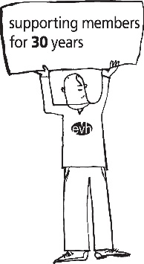

**Booking Form**

**Event: Mindfulness Session**

**Date: Thursday 20 November 2025, 10.00am – 11.00am**

**Location: Online via Zoom**

**Costs: EVH Members only - Free**

This session is free for members to attend however we require all delegates to pre book their place.  Please note that bookings which are withdrawn without a substitution 48 hours before the event will be charged a £20 administration fee (this will be donated to CHAS) as will those who do not attend.  We will accept substitutions at any time.

Please complete the following and return by email to[**Events@evh.org.uk**](mailto:Events@evh.org.uk)**.** There is no limit to the number of spaces you can book, they will be on a first-come-first-served basis.

| **Name of delegate joining via Zoom** |  |
| --- | --- |
| **Organisation** |  |
| **Email address to send zoom invitation to** |  |
| **Name of delegate joining via Zoom** |  |
| **Organisation** |  |
| **Email address to send zoom invitation to** |  |

The contact person making the booking will receive confirmation from a member of the Events Team to confirm their delegate’s place. The zoom joining instructions will be sent nearer the event, direct to the delegate at the email provided above. If you have any questions, please get in touch by email – [**Events@evh.org.uk**](mailto:Events@evh.org.uk)**.**